**Docker Uses**

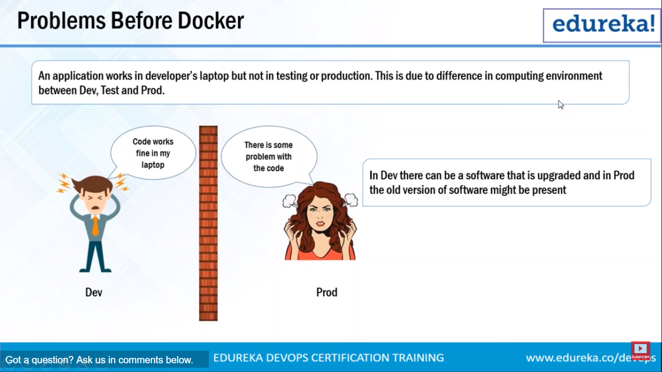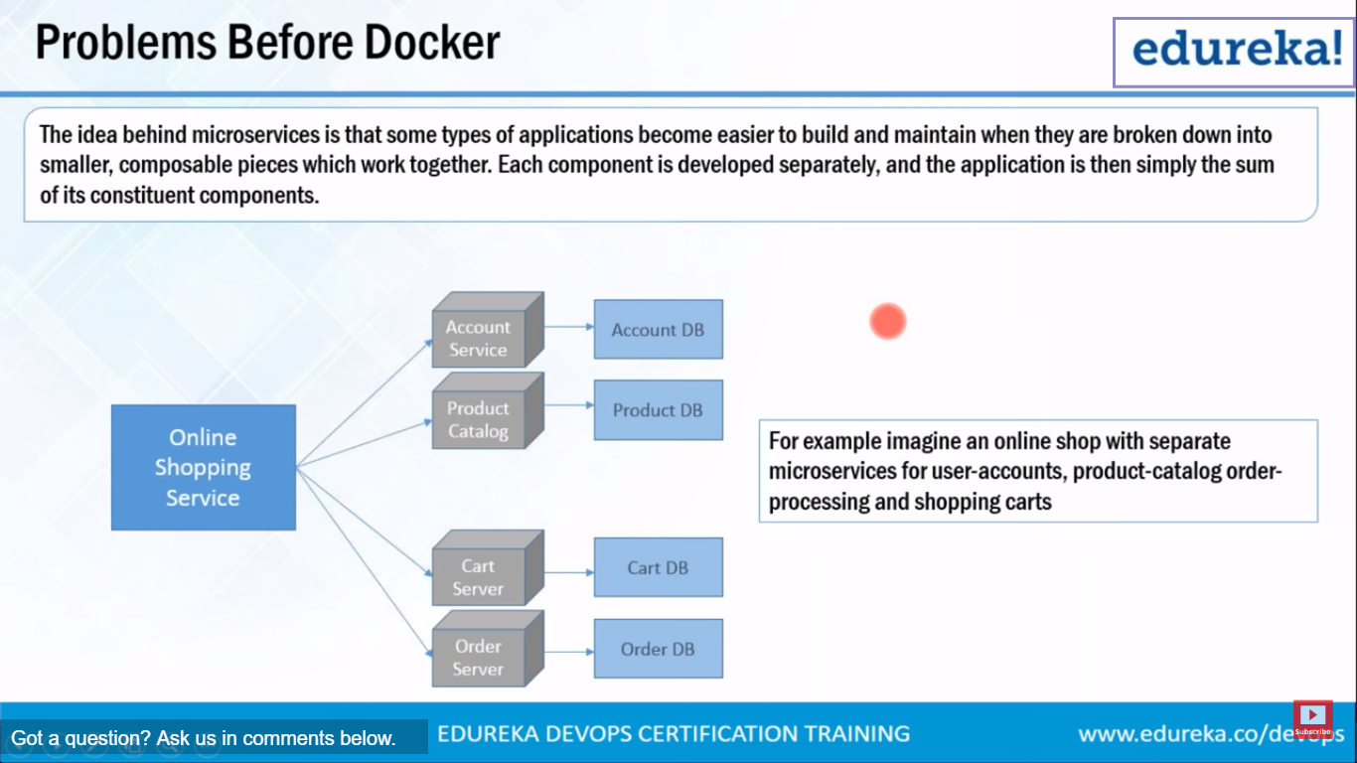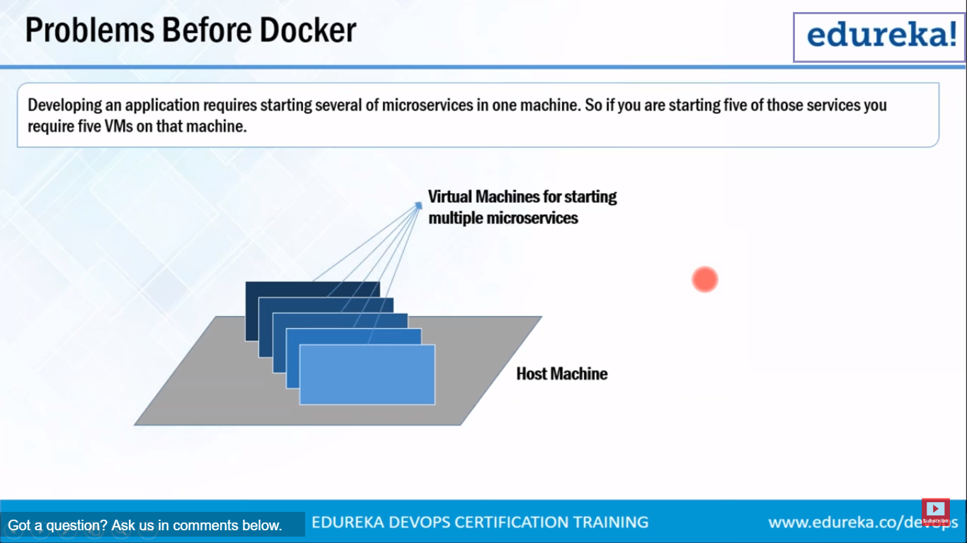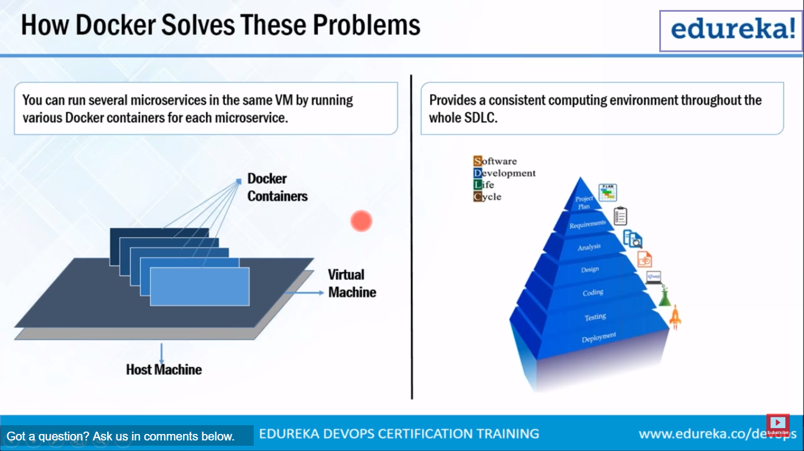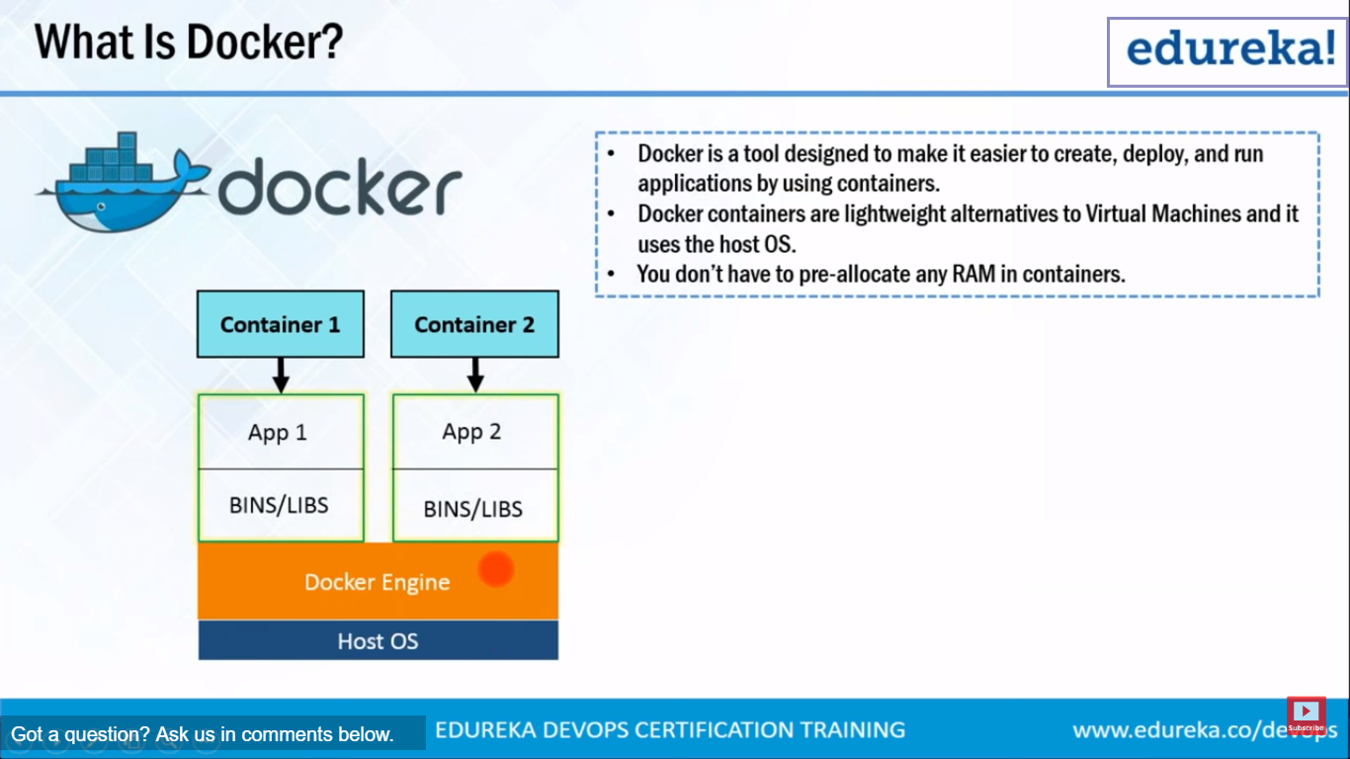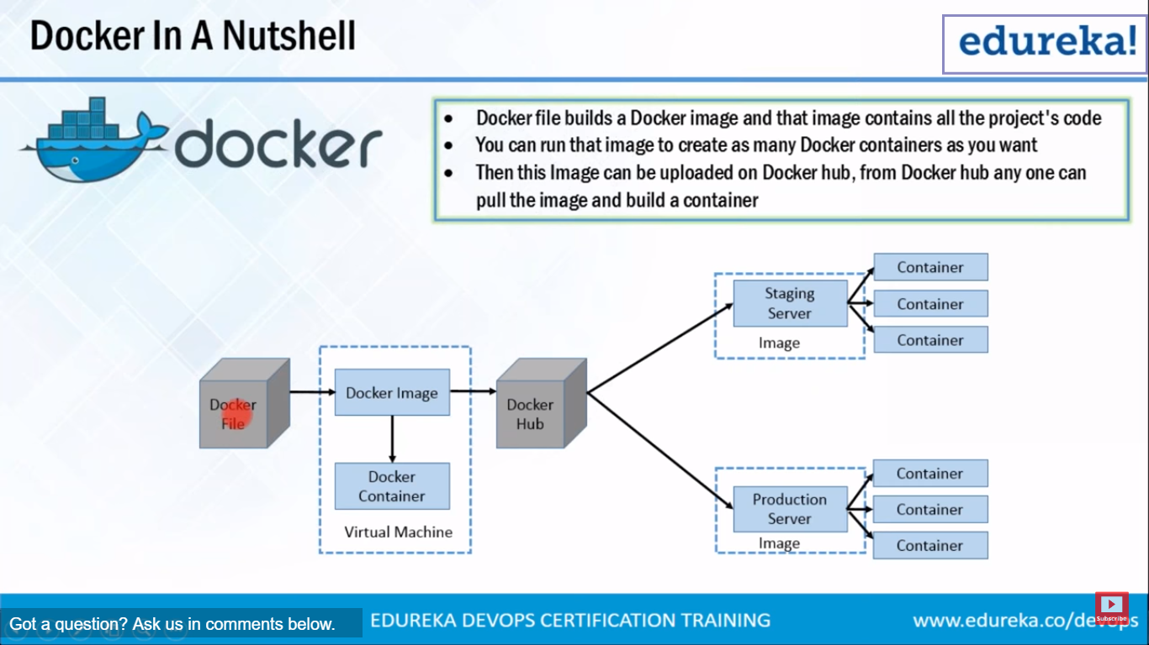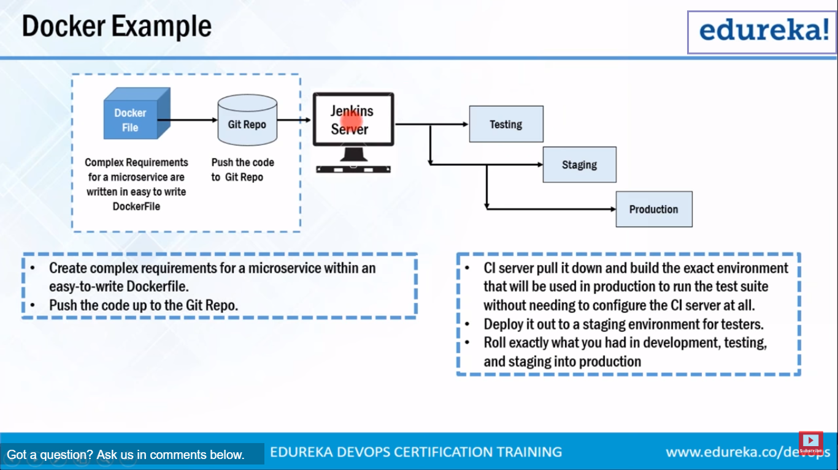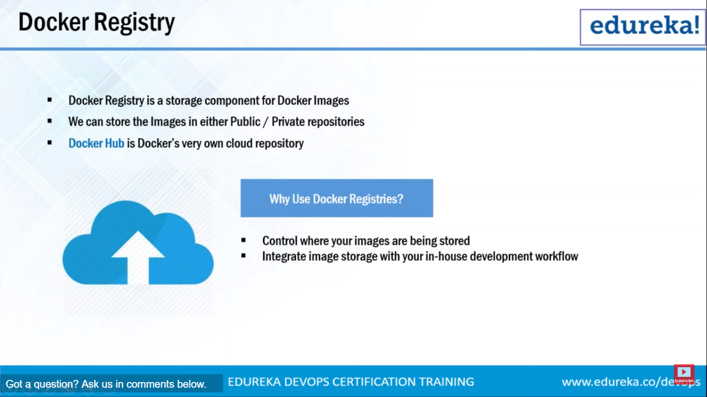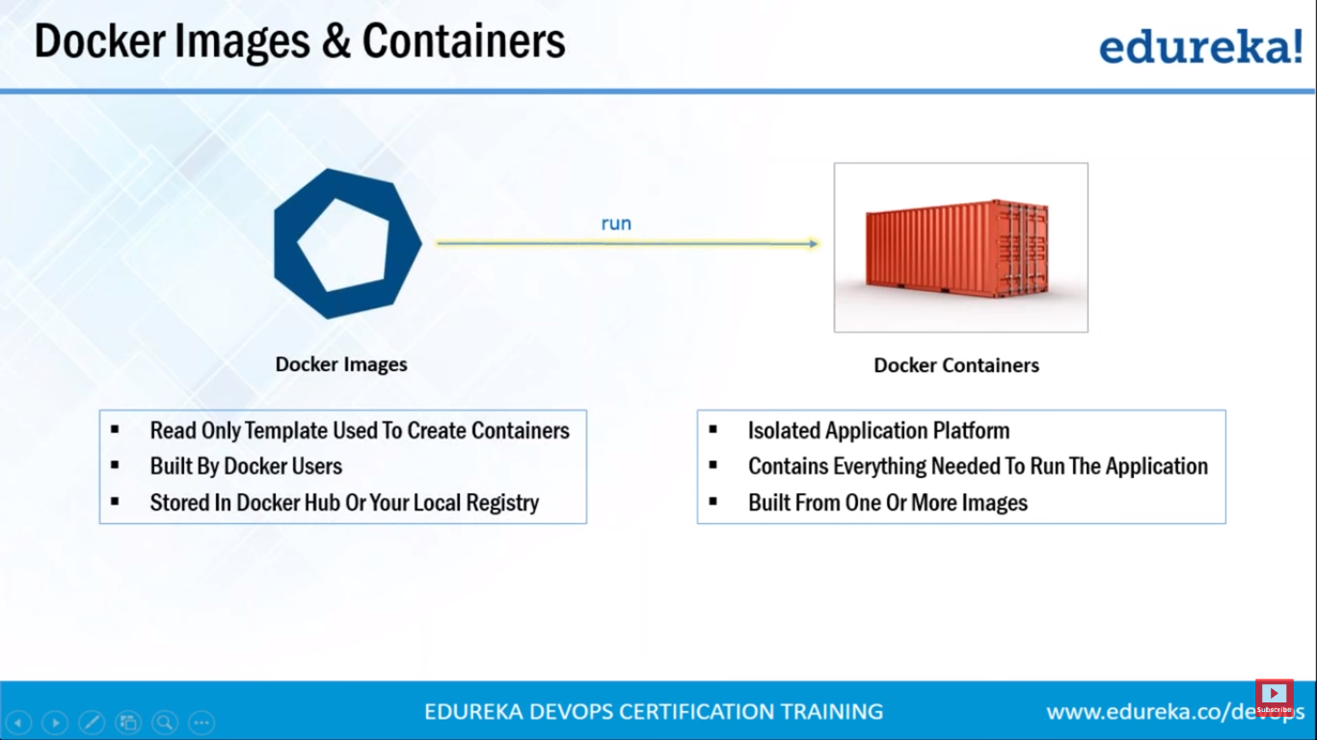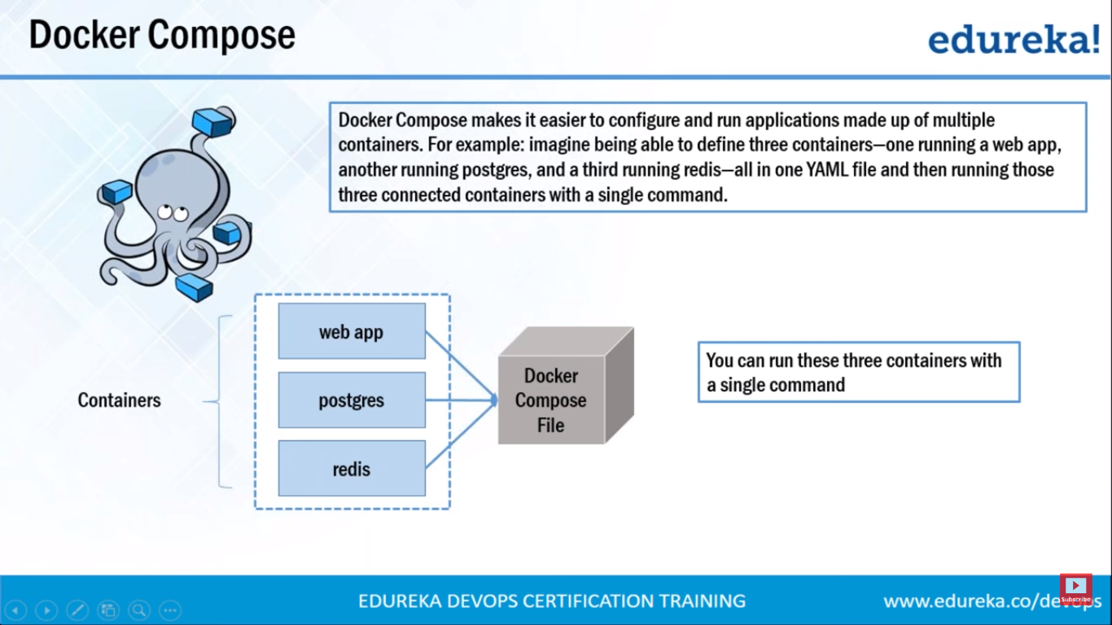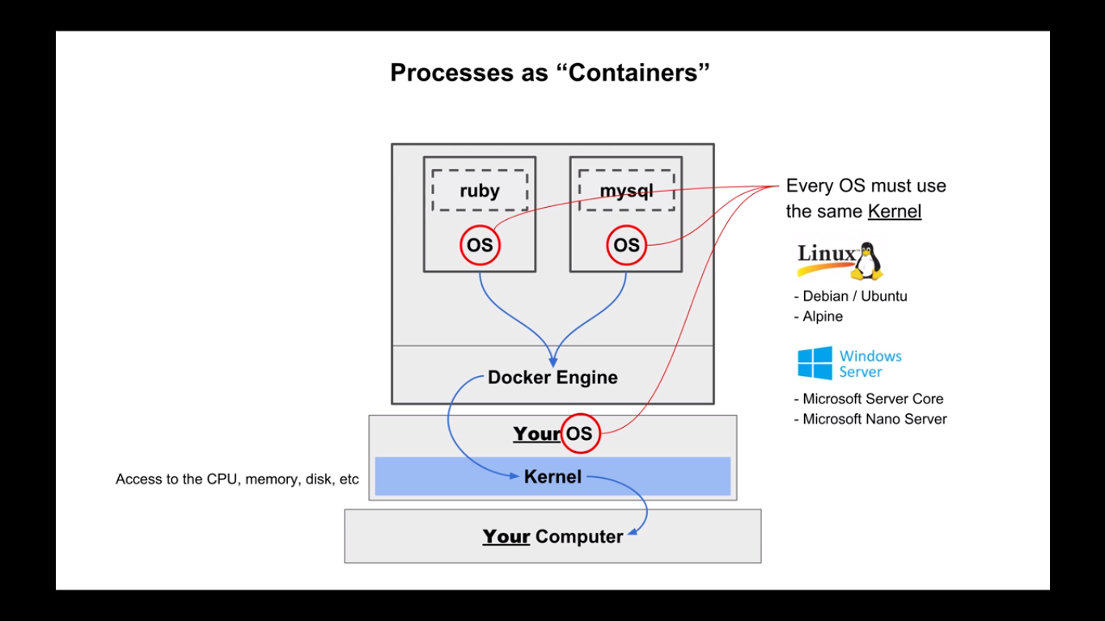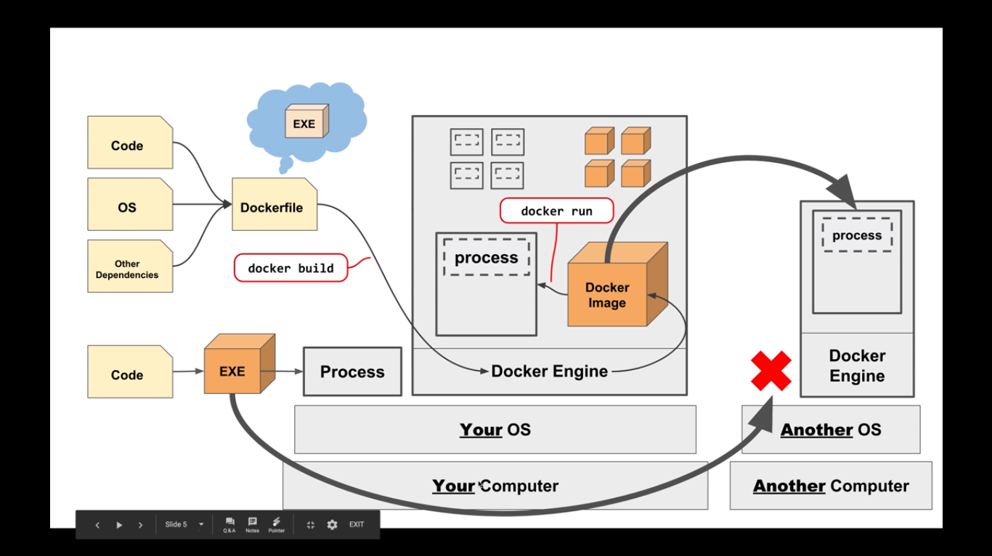

What is Docker ?

* Docker is the world’s leading software container platform.
* Docker makes the process of application deployment very easy and efficient and resolves a lot of issues related to deploying applications.
* Docker is a tool designed to make it easier to deploy and run applications by using containers.
* Docker gives you a standard way of packaging your application with all its dependencies in a container.
* Containers allow a developer to package up an application with all of the parts it needs, such as libraries and other dependencies, and ship it all out as one package.
* Understand Docker with analogy of the Shipping industry

How a real world problem was resolved using containers

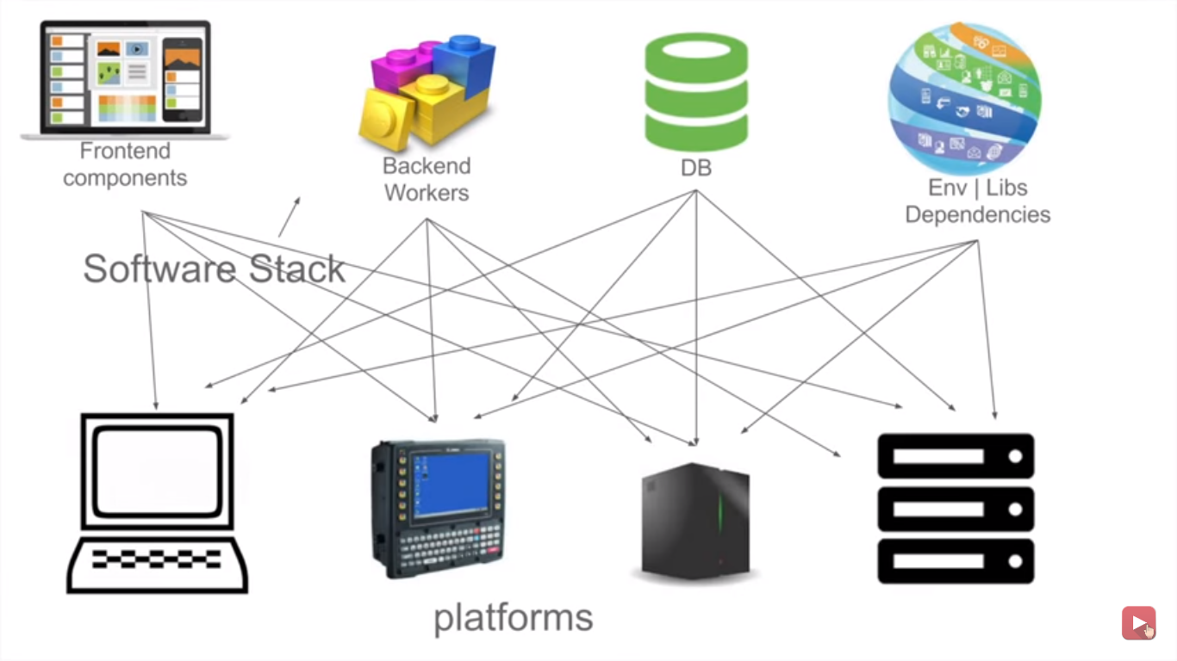

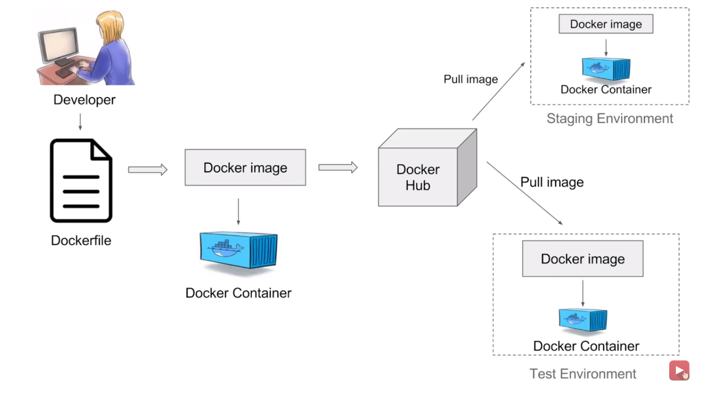

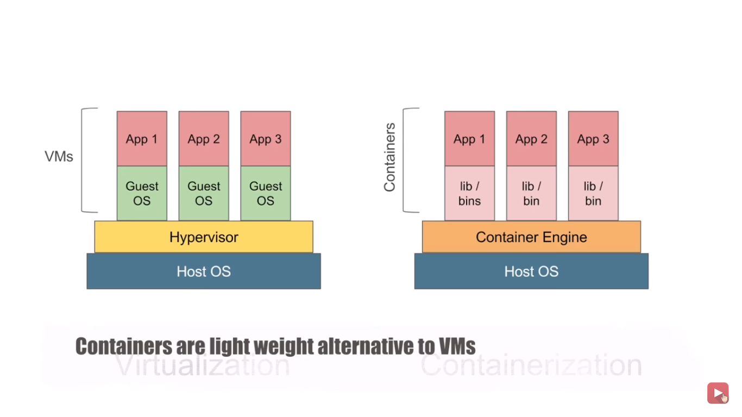

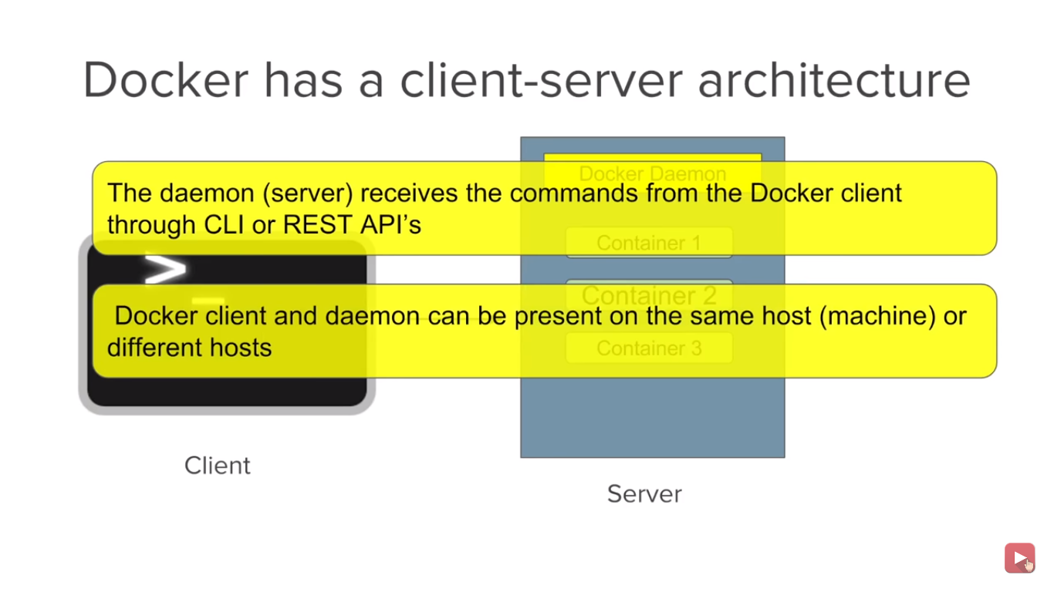

Benefits of using Docker Build app only once No worries that the application will not perform the same way it did on testing env Portability Version Control Isolation Productivity Docker simplifies DevOps.

* 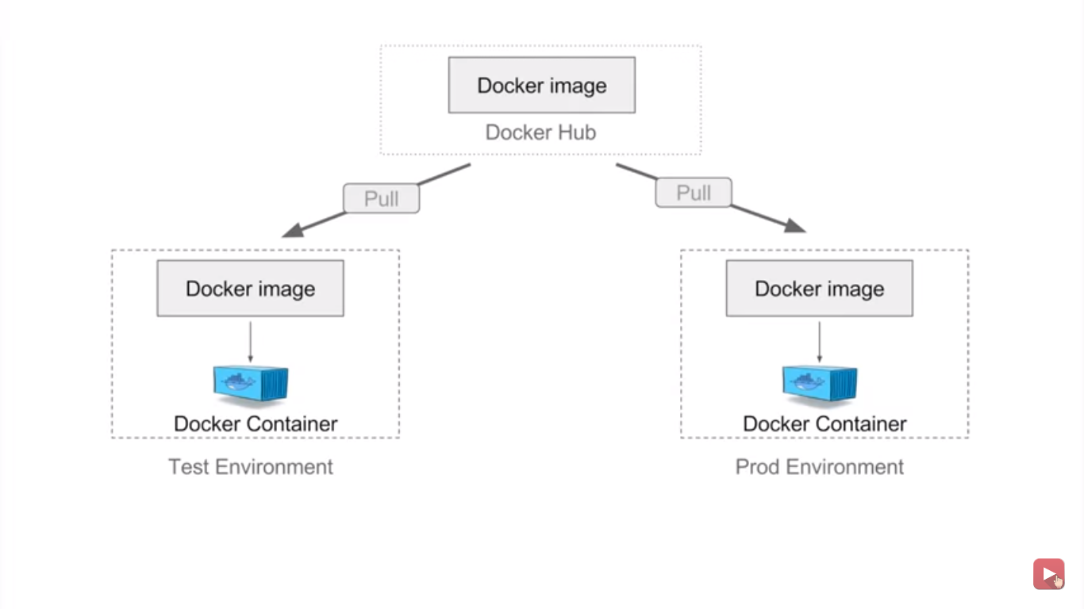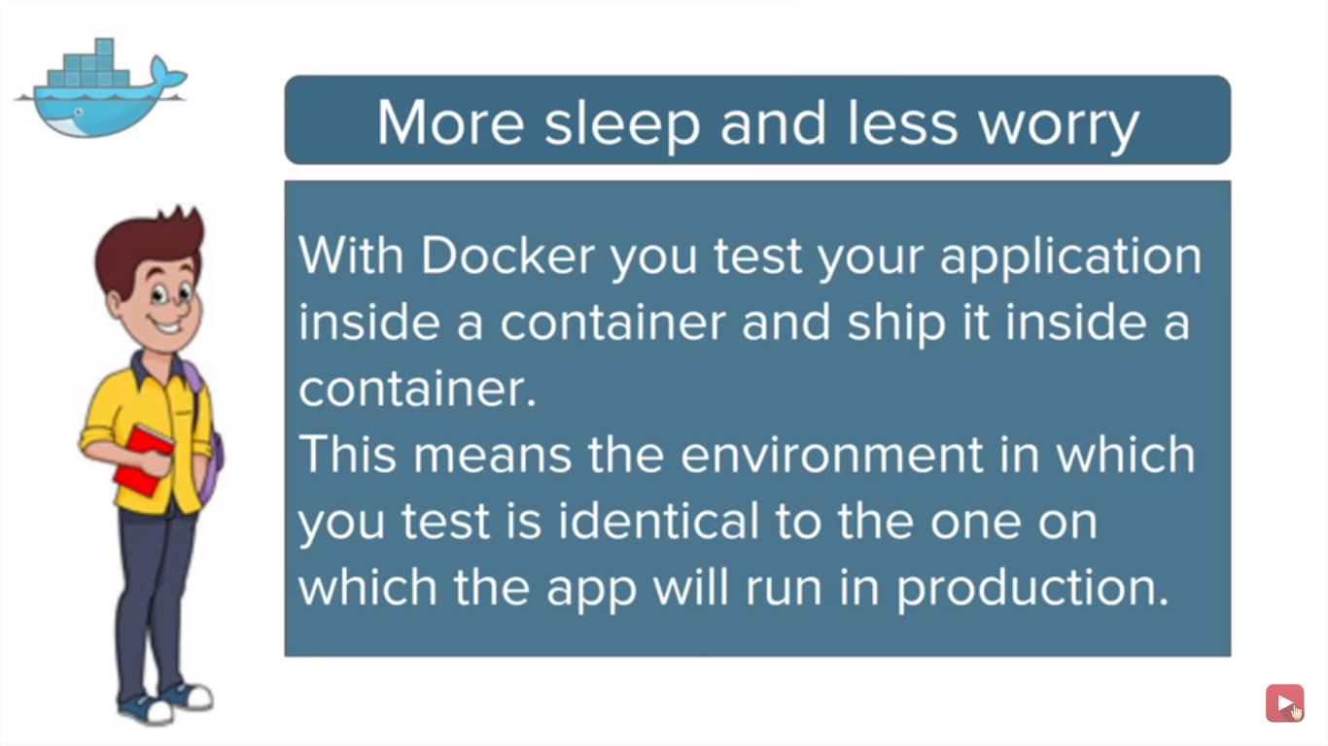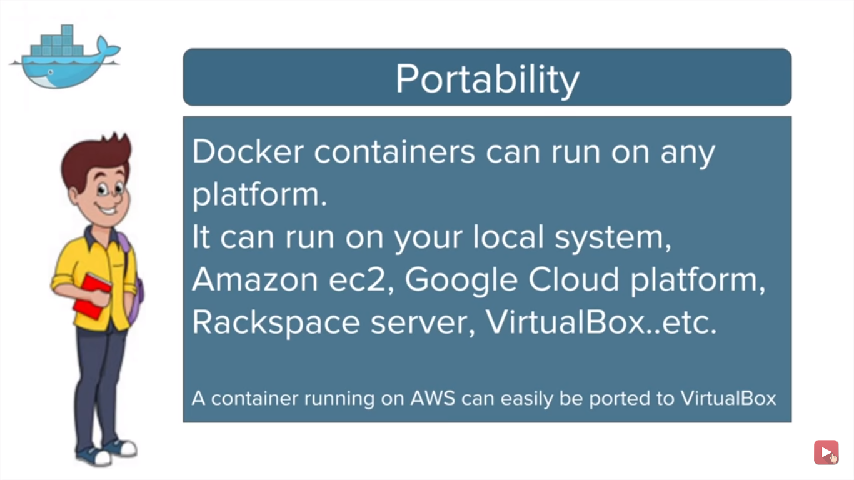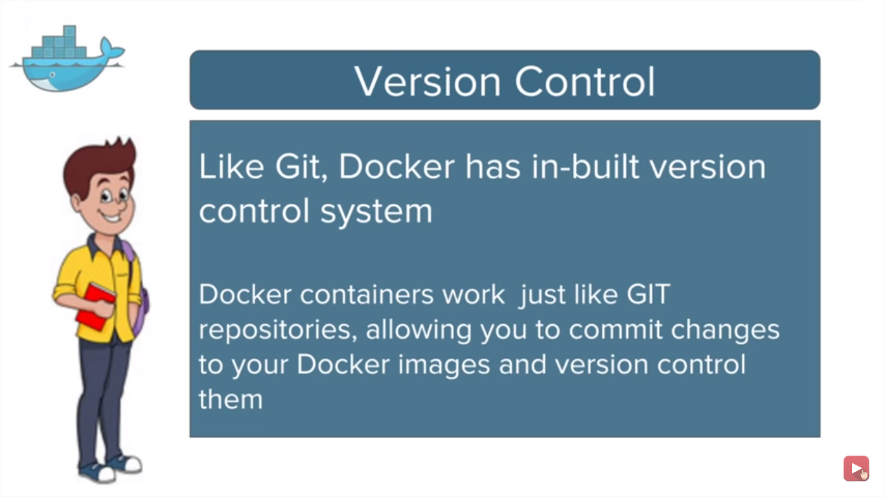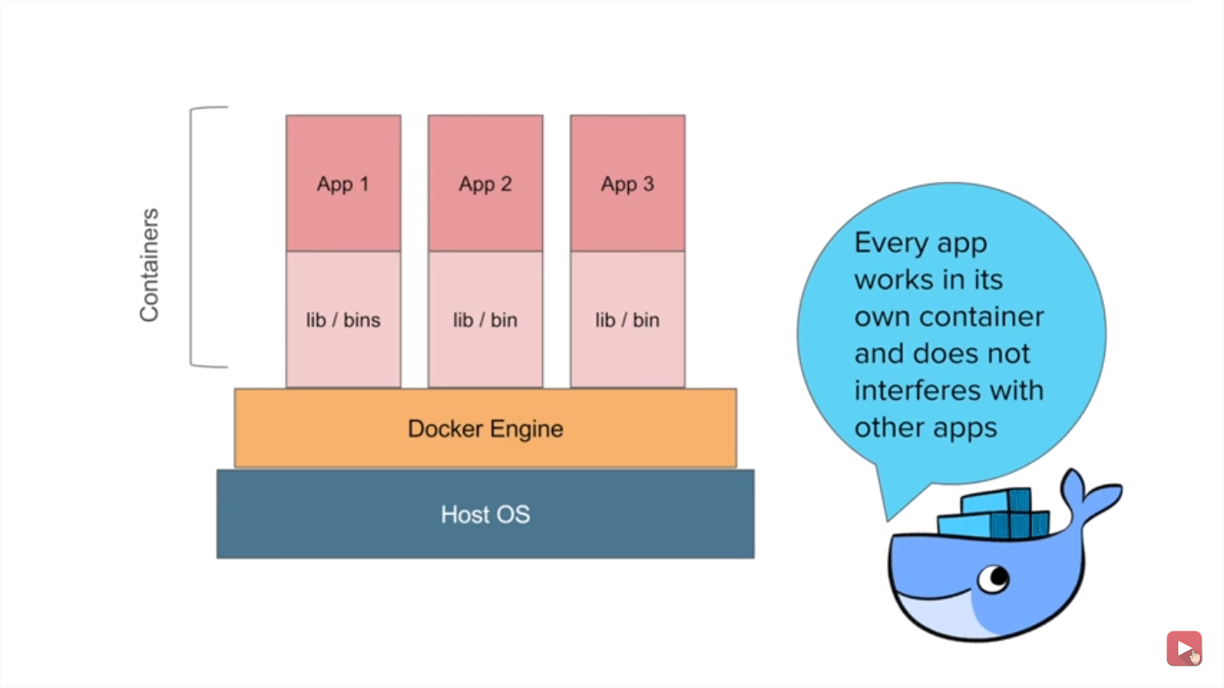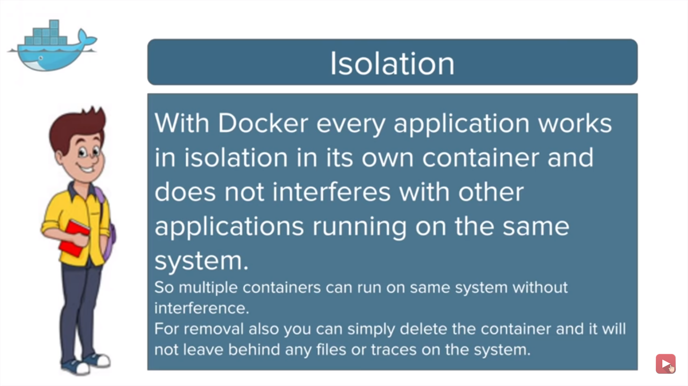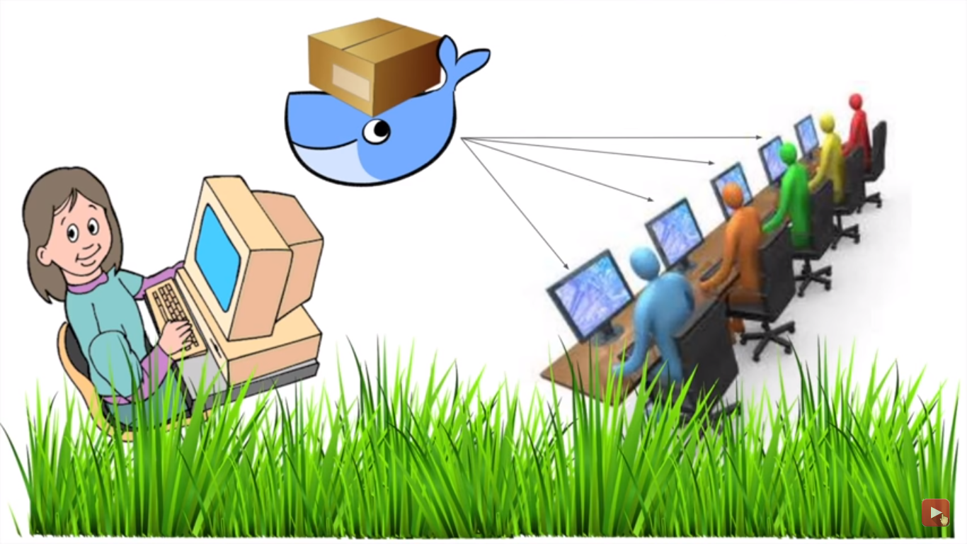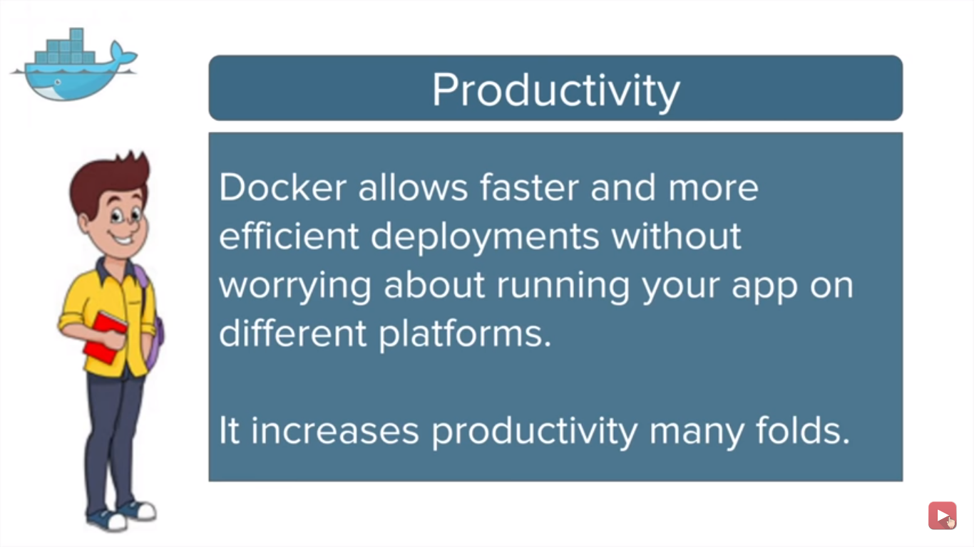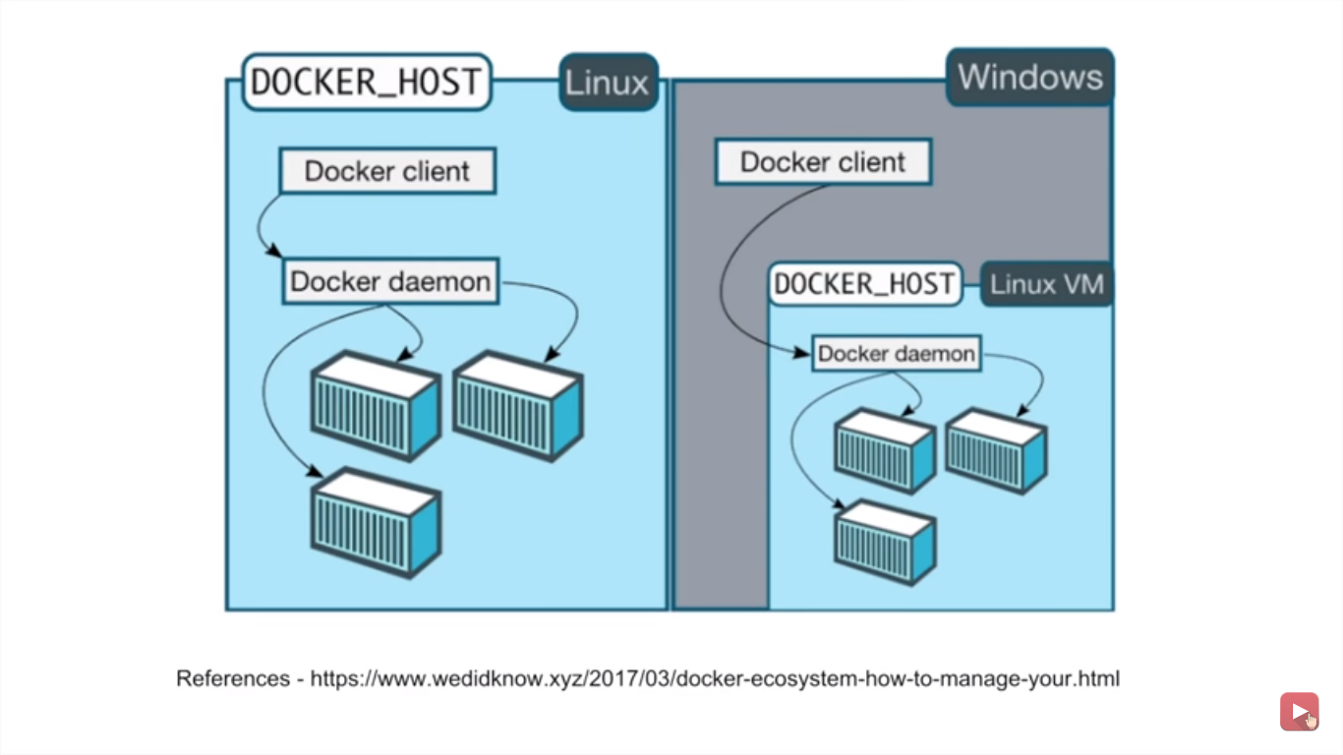Containers and images created with Docker for Windows are shared between all user accounts on machines where it is installed. This is because all Windows accounts use the same VM to build and run containers.

Basic Commands-

: docker version

: docker -v

: docker info

: docker --help

: docker login

————————————

Images

: docker images

: docker pull

: docker rmi

————————————

Containers

: docker ps

: docker run

: docker start

: docker stop

————————————

System

: docker stats

: docker system df

: docker system prune

* Dangling images- which are not associated with running container
* A container image is a lightweight, stand-alone, executable package of a piece of software that includes everything needed to run it: code, runtime, system tools, system libraries, settings.

Features of Containers:

* Are lightweight
* Fewer resources are used
* Booting of containers is very fast
* Can start, stop, kill, remove containers easily and quickly
* Operating System resources can be shared within Docker
* Containers run on the same machine sharing the same Operating system Kernel, this makes it faster